Inno Ed Tools

User manual : Moodle plugin

Contents

Administrator Role 2

How to install plugin 2

Prerequisite setup 3

How to define standard tags 3

How to setup courses 5

Teacher role 6

Inno Smart Report 6

Report by overall 7

Report by tags 8

Report by students 8

Inno Smart Portfolio 9

Example PDF 11

Students Role 12

Inno Smart Report 12

Inno Smart Portfolio 13

# Administrator Role

* Go to URL : <http://www.chulacyberinnovation.net/>
* Log in with Administrator role

## How to install plugin

* Go to menu “Site Administration” (1)
* Select menu “Plugins” (2)
* Click “Install plugins” (3)
* Choose a plugin zip file (4)
* Display plugin file name (5)
* Click button “Install plugin from the ZIP file” (6)

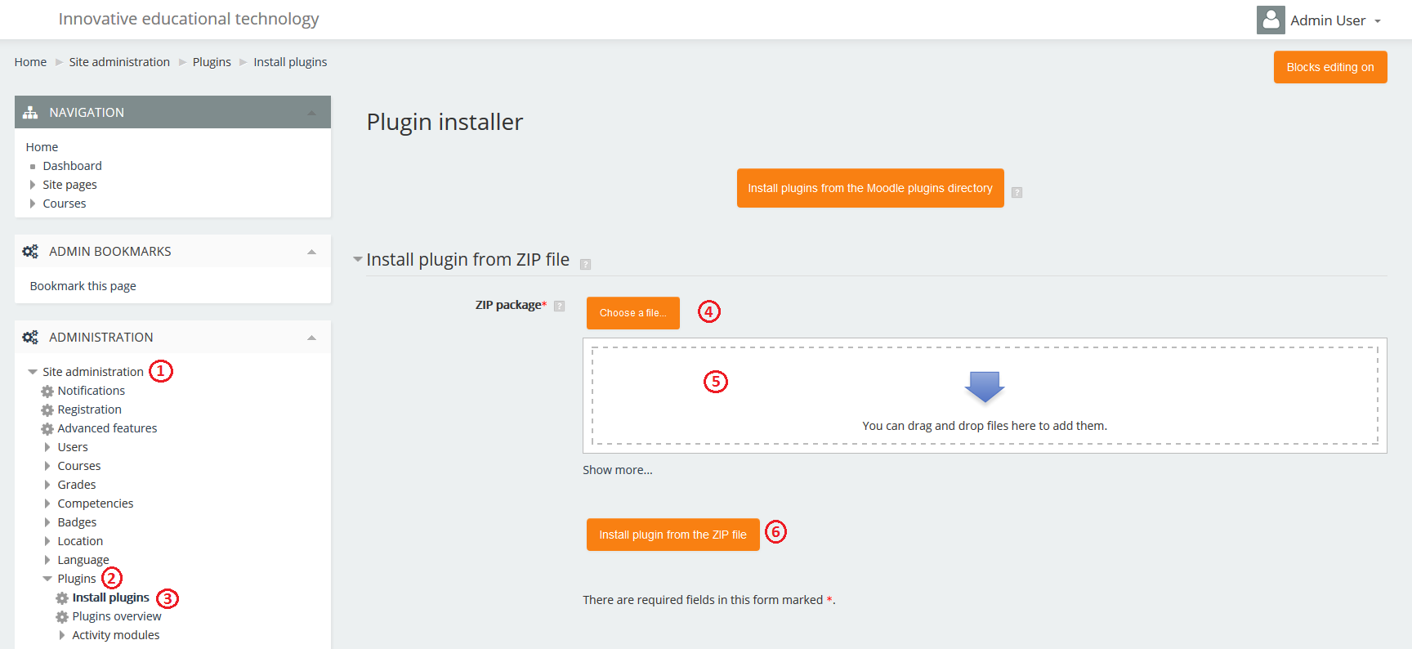

After completed, New menu will display in the navigation block

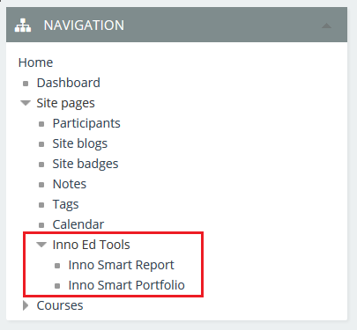

## Prerequisite setup

### How to define standard tags

* Go to “Site pages” in navigation block (1)
* Select menu “Tags” (2)
* Click button “Manage tags” (3)

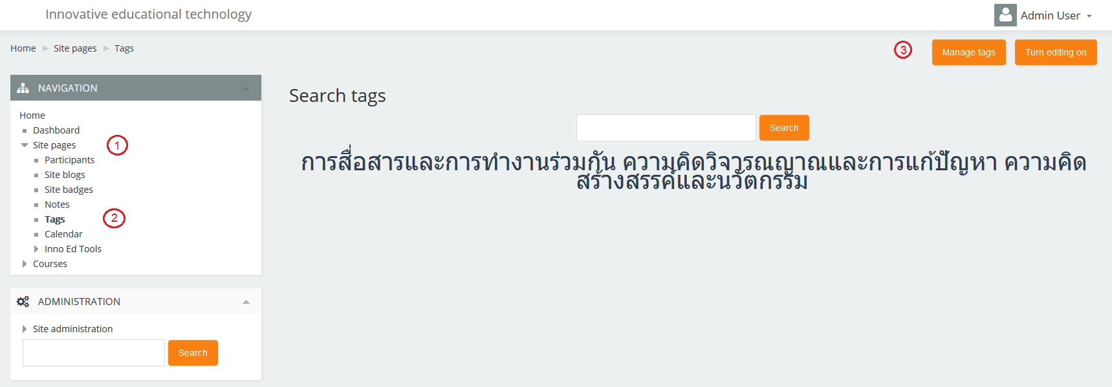

* Click on “Default collection”

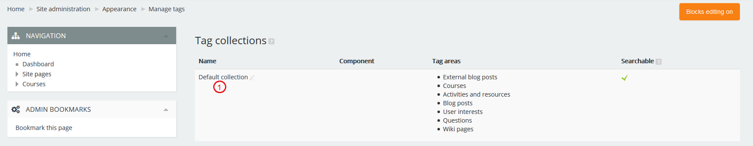

* Display list of tags in the system, add more standard tags by click on “Add standard tags” (1) at the top right
* Then input tag name (2) and click button “continue” after finish (3)

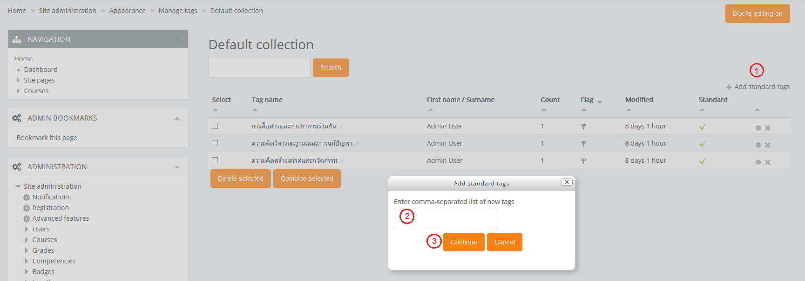

The results are shown on the screen. The standard tag is specified with the “Standard” column

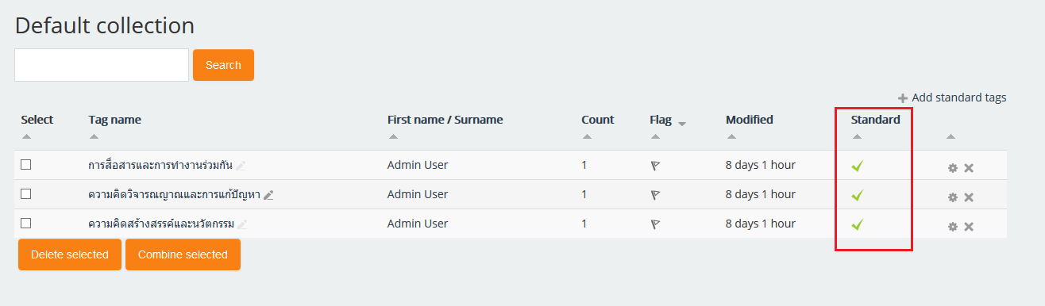

### How to setup courses

* Go to menu “Site Administration” (1)
* Expand menu “Courses” (2)
* Select menu “Manage courses and categories” (3)
* Courses list are shown on the screen, then click ‘Edit’ icon (4)

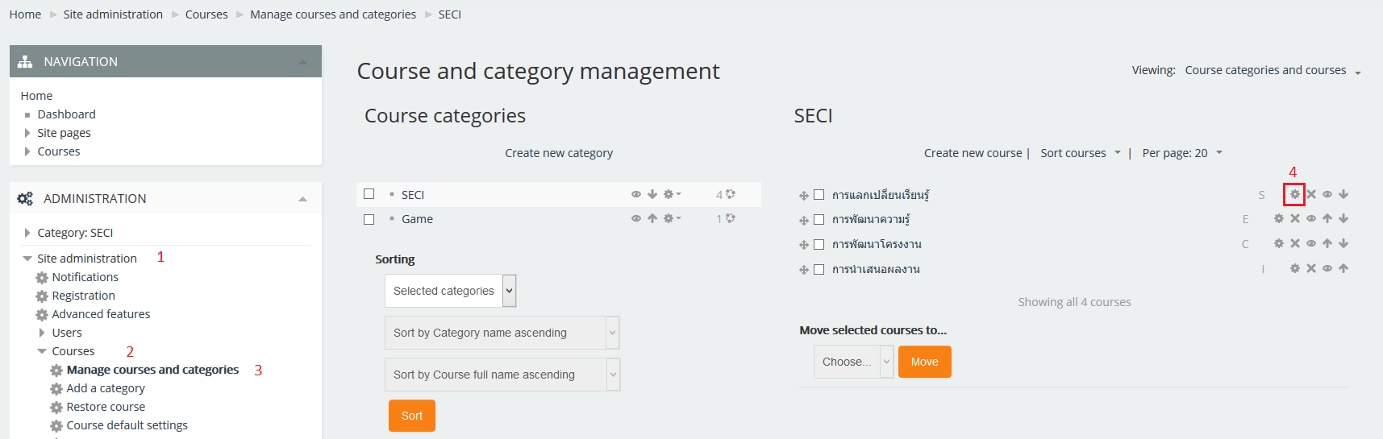

* Input “Course ID number”, the plugin is focus at “Course ID number” to specify courses to report

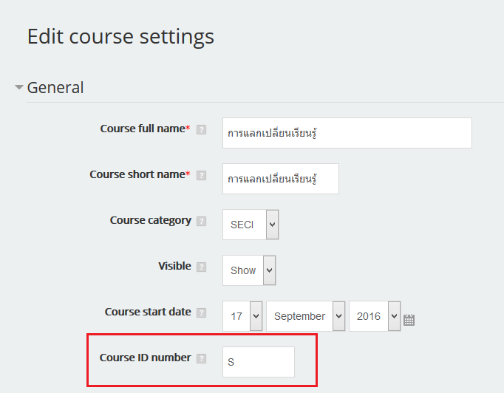

* Ready to go!

# Teacher role

There are 2 main menu

* Inno smart Report
* Inno smart Portfolio

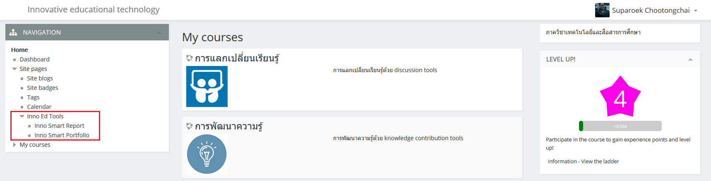

## Inno Smart Report

There are 3 types of the report for teacher view

* Report by overall
* Report by tags
* Report by students

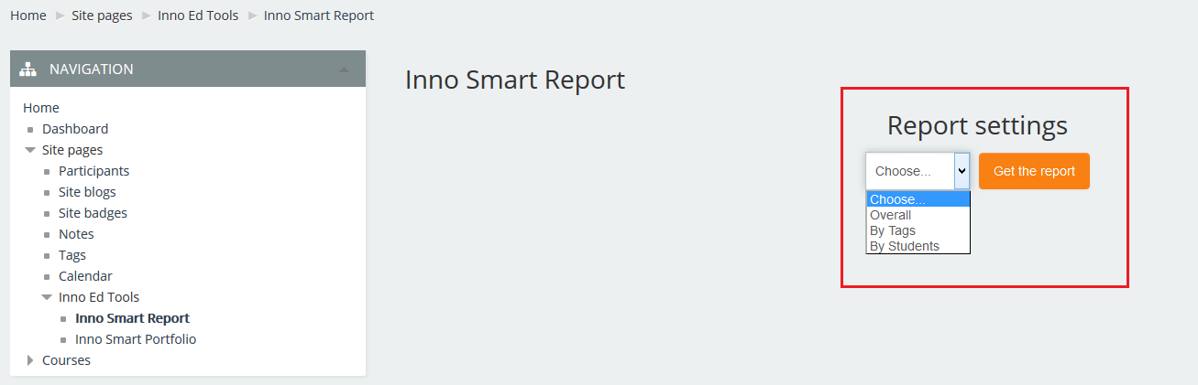

### Report by overall

The report displays “Standard tags” statistics of the all students that using in the blogs. Including overall statistics for all courses in percentage per student

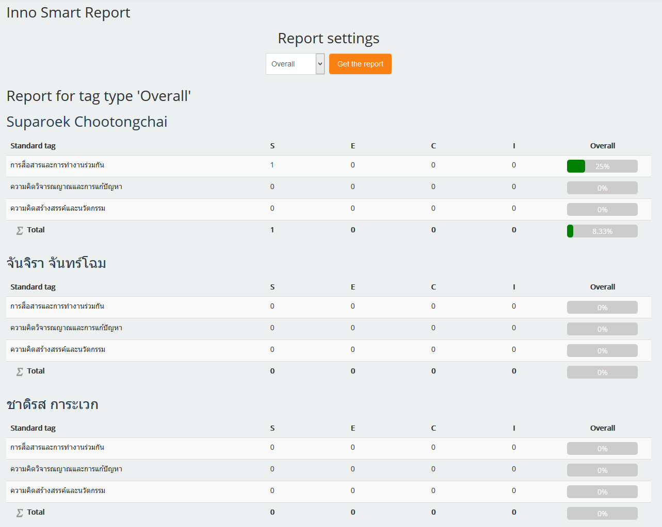

### Report by tags

The report displays overall “Standard tags” statistics for all students group by tags.

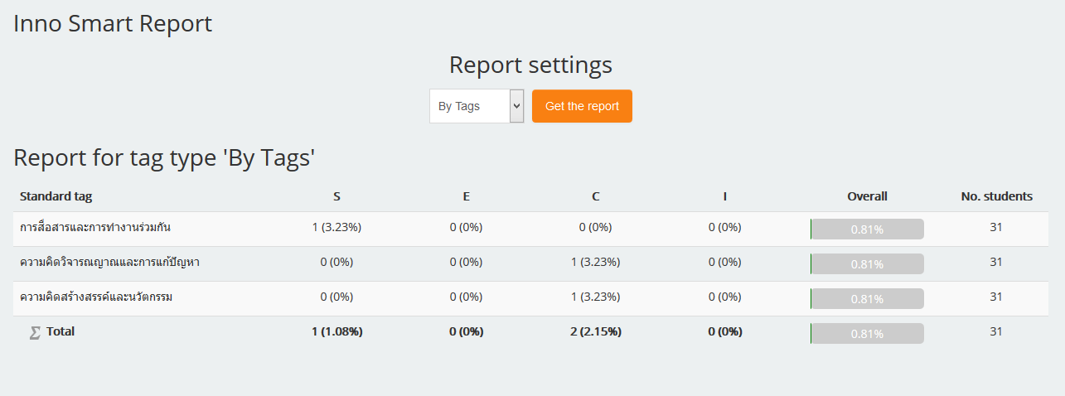

### Report by students

The report displays overall “Standard tags” statistics for all tags group by students.

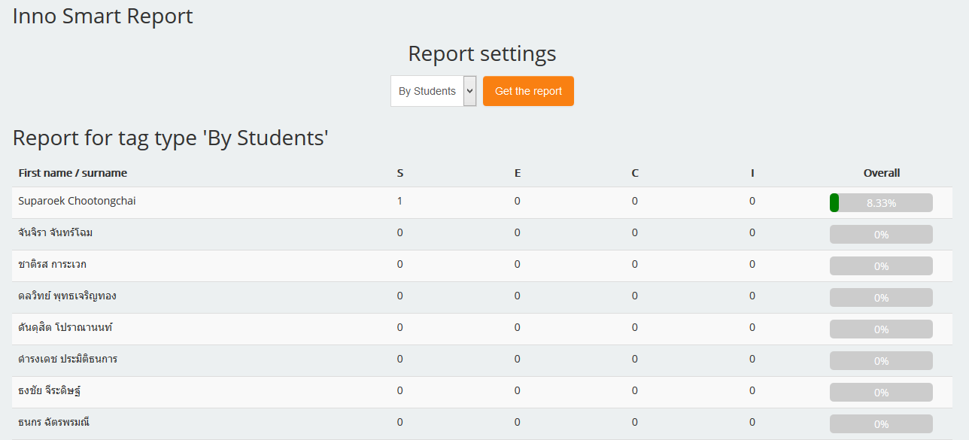

## Inno Smart Portfolio

The screen displays list of student name in the course, including basic information

* User ID
* First name / surname
* Email address
* Telephone
* View – See blog information of the student

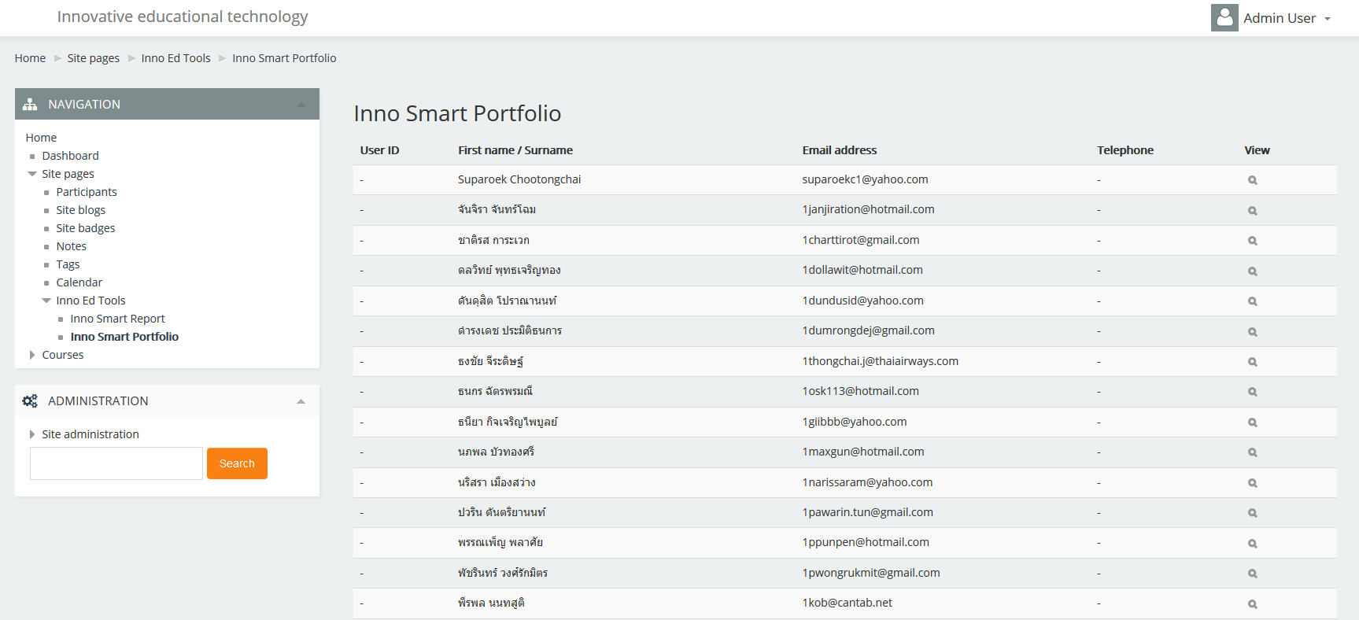

Teacher can see blog detail of the student by click “Search” icon on “View” column. Then student blog page is shown.

This page displays student blogs that associated to course (The similar to blogs page but only the blogs that associated to course).

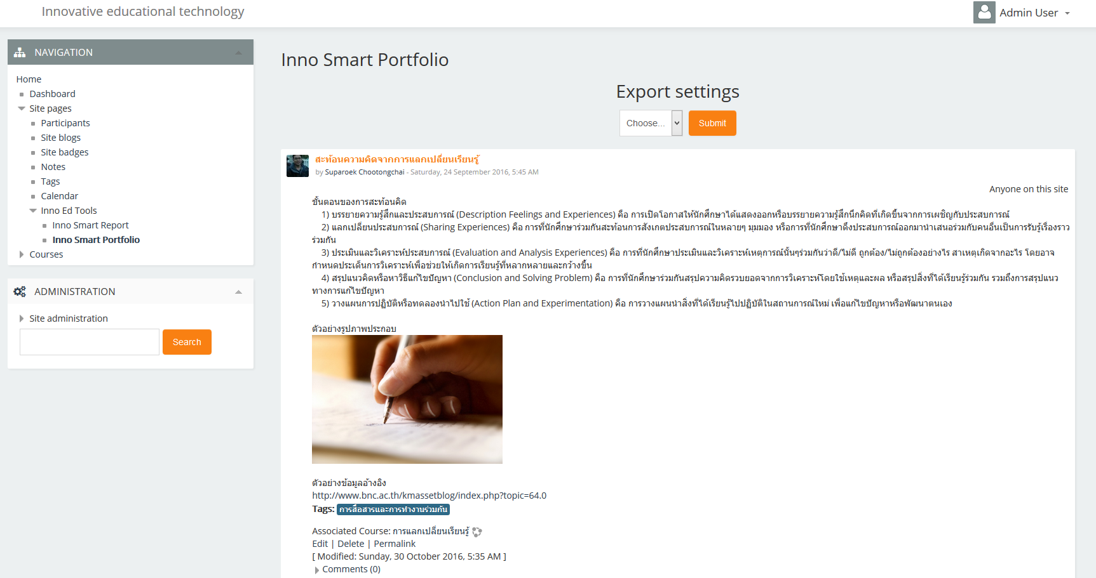

Select to export to a PDF file, choose Preview or Print it as well.

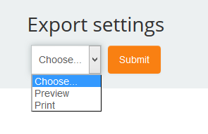

* Preview
  + Cover – Display first name/surname, email and telephone of the student
  + Blogs – Display course short name, blog subject and blog contents
    - Link (tag <a>)– generate to QR Code
    - Image – Prefer only jpg and jpeg type
  + Last page – display “Inno Smart Report“
* Print
  + Save as popup

### Example PDF



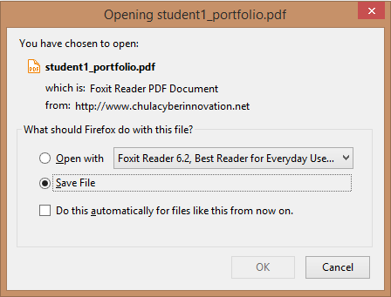

# Students Role

There are 2 main menus (the same as teacher role)

* Inno smart Report
* Inno smart Portfolio



## Inno Smart Report

Similar to “Report by overall” of Teacher role but student can see the report of their own.

The report displays “Standard tags” statistics of the student that using in the blogs. Including overall statistics for all courses in percentage.

* List of Standard tags (1)
* Course ID name (2)
* Number of tags (3)
* Overall statistics in percentage (4)

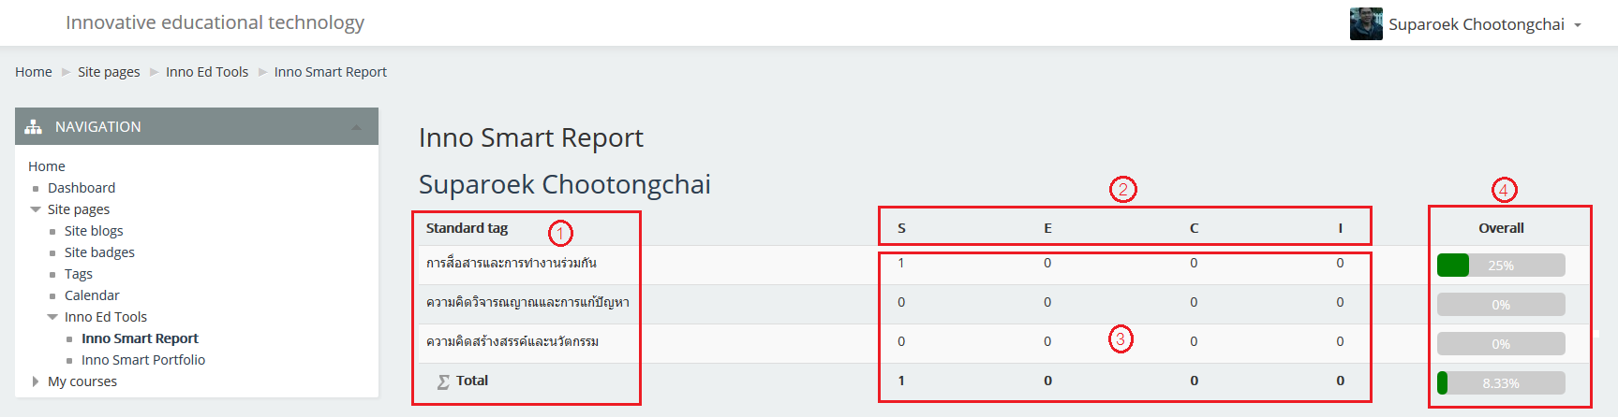

## Inno Smart Portfolio

The report displays student blogs that associated to course (The similar to blogs page but only the blogs that associated to course).

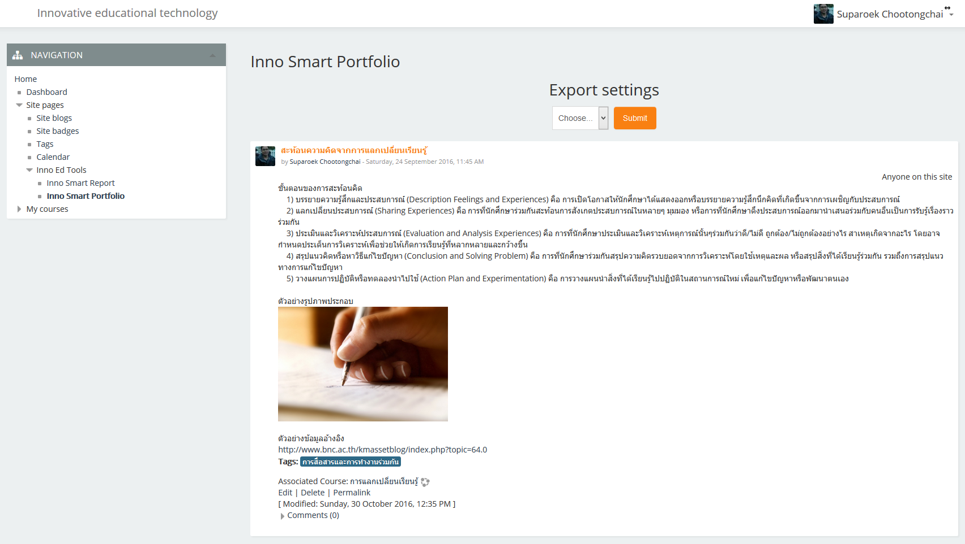

Select to export to a PDF file, choose Preview or Print it as well.



* Preview
  + Cover – Display first name/surname, email and telephone of the student
  + Blogs – Display course short name, blog subject and blog contents
    - Link (tag <a>)– generate to QR Code
    - Image – Prefer only jpg and jpeg type
  + Last page – display “Inno Smart Report“
* Print
  + Save as popup